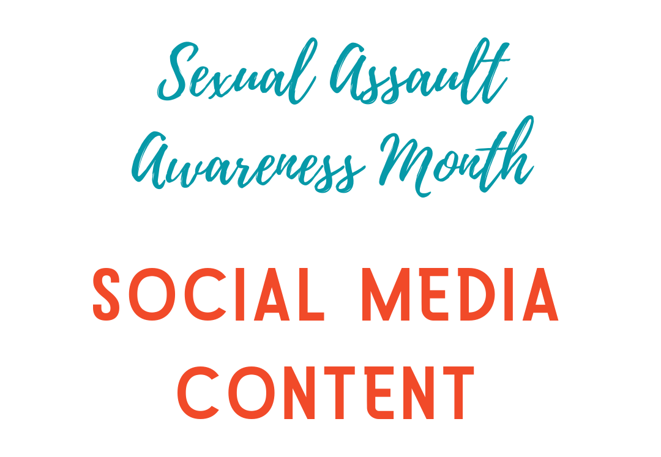
We hope you’ll get great use out of the content we’ve created for Sexual Assault Awareness Month in Ohio. This content is meant to help you engage with your communities during SAAM.
All you have to do is save the images in the file, then upload to your social media platforms using the captions we’ve supplied. Copy-and-paste the captions into the post window, and feel free to add more information related to your local communities in your captions. These posts are in no particular order.
Please don’t change the images in any way or copy the content of the images to re-create them in another format. You may alter the captions to your liking, but we think we’ve provided some pretty good ones!
If you need assistance, please don’t hesitate to reach out to OAESV’s Resource & Communications Team! Jenn, Luisa, and Taylr are here to help you. Just email communications@oaesv.org; we can help via email or set up a call.
Our Tips (just suggestions—use as you wish):
- Post at least once a day on Facebook and Instagram, but no more than two times a day.
- Post to Twitter at least twice a day, up to 10 times or more a day.
- Utilize the “stories” feature on Facebook and Instagram. It’s very popular!
- Use a free scheduler like Hootsuite to help you. This way, you can just schedule out your posts, and you don’t need to worry about doing it each day (except for Instagram—you’ll schedule on the computer, but you’ll still need to post from your phone. Don’t worry, Hootsuite will send you everything you need for that).

Image:
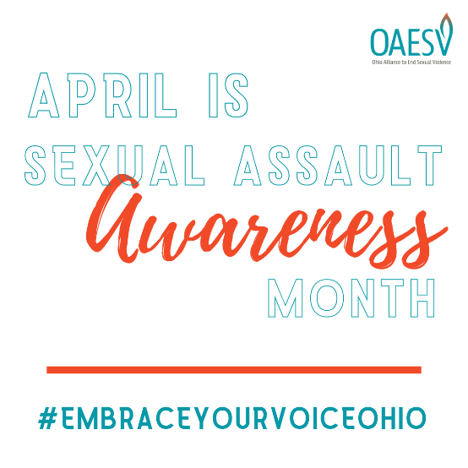
Caption:
April is Sexual Assault Awareness Month (also known as SAAM)! Follow our page to learn more about this issue and how you can help stop it. #EmbraceYourVoiceOhio

Image:

Caption:
We all have a responsibility to end sexual violence in Ohio. We hope you’ll join us! #EmbraceYourVoiceOhio

Image:
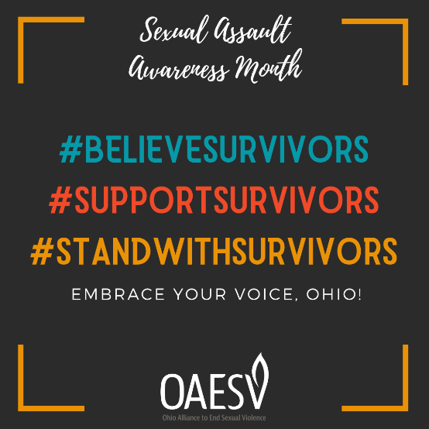
Caption:
It’s as simple as that. #EmbraceYourVoiceOhio

Image:
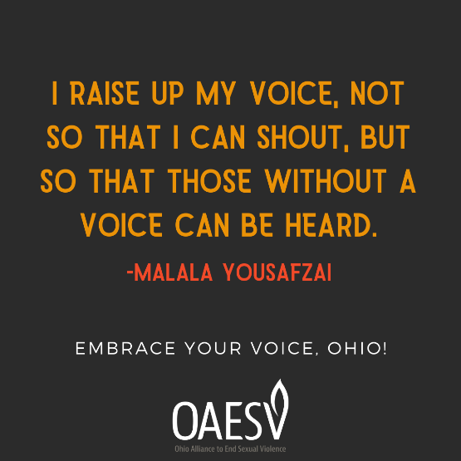
Caption:
Do you speak up against injustices? Tell us why in the comments. Learn more about Malala Yousafzai by visiting: https://malala.org/malalas-story #EmbraceYourVoiceOhio

Image:
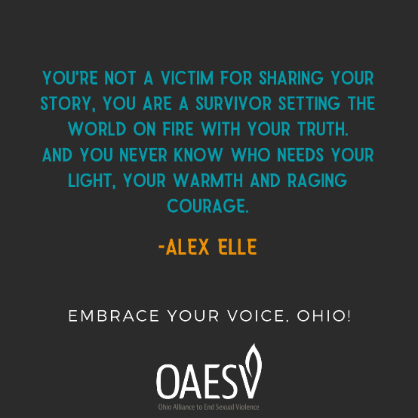
Caption:
We agree, Alex! Alexandra Elle is an author & wellness consultant who works to assist others in “finding their voices through storytelling, poetry, and narrative writing rooted in truth without shame. Her mission is to build community & self-care practices through literature & language.” What a wonderful way to #EmbraceYourVoice.

Image:
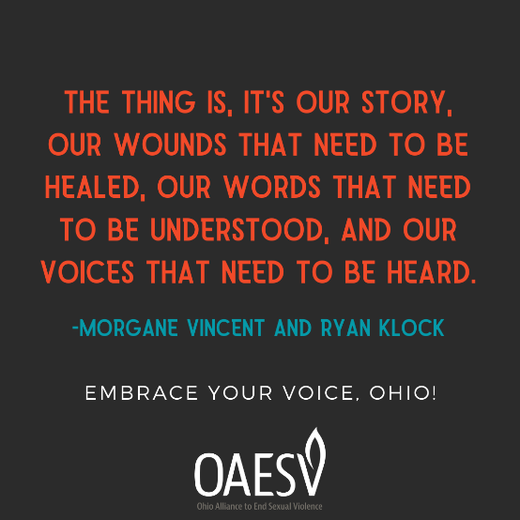
Caption:
These words come from Morgane Vincent and Ryan Klock, two student activists from Gallaudet University, who remind us of the ways that Deaf and hard of hearing people are affected by sexual violence. Read their article for more information: https://nomore.org/gallaudet-university-students-say-no-more-silencing-deaf-voices/
#EmbraceYourVoice
Image:
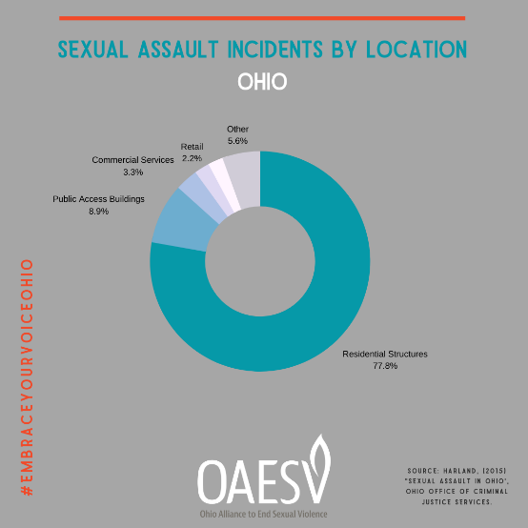
Caption:
It’s important to share the realities of sexual violence. Many myths are spread about where sexual violence often occurs. #EmbraceYourVoice to share the truth.

Image:
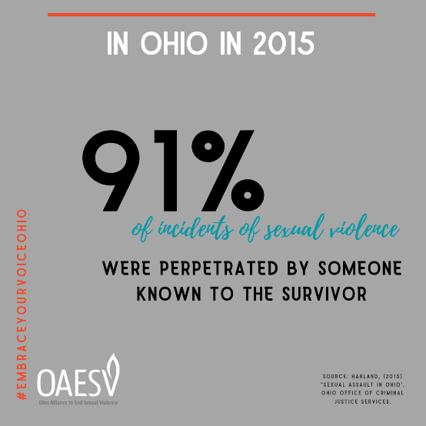
Caption:
Attacks by strangers do happen. But unfortunately, we are at a much greater risk of being attacked by someone we know. #EmbraceYourVoice

Image:
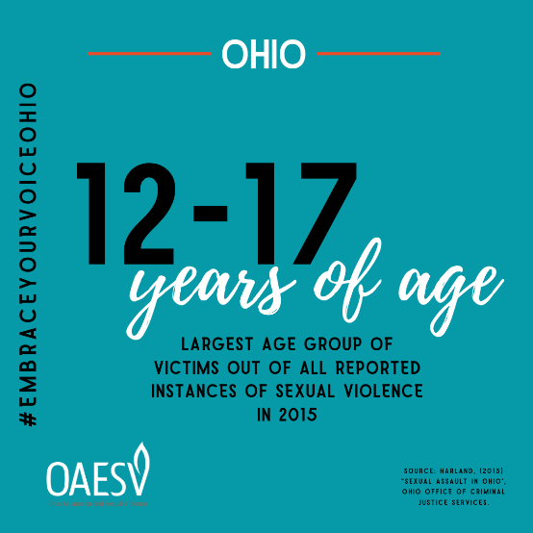
Caption:
People of all ages are at risk of being victimized by sexual violence, but in Ohio in 2015, this age group made up more than 30% of survivors. #EmbraceYourVoice

Image:
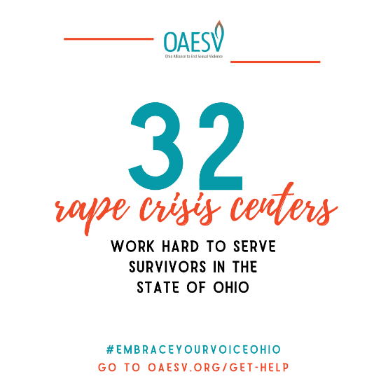
Caption:
Organizations in our state work hard to provide the necessary services to survivors. We need you to #EmbraceYourVoice and remind your community why having these programs is so important!

Image:
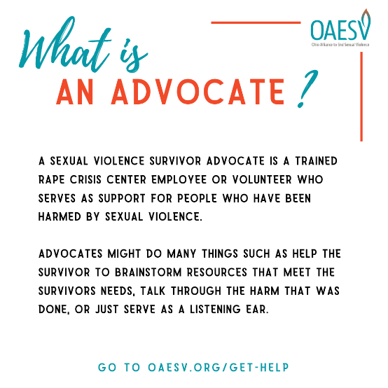
Caption:
#EmbraceYourVoice

Image:
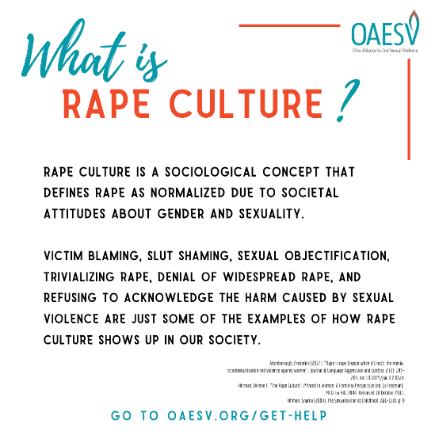
Caption:
So how do we change this? The answer—is YOU! We must work together to change the expectations in our society. Let’s make these things abnormal instead of accepting them as “just the way it is”. #EmbraceYourVoice and speak up against #RapeCulture.

Image:
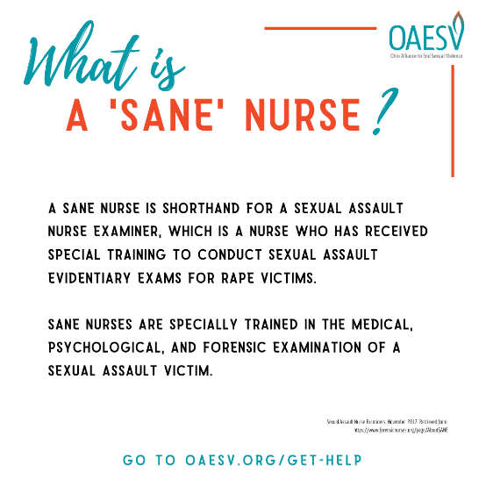
Caption:
Call your local rape crisis center to find out if there is a trained SANE nurse near you! Find the closest center by visiting www.oaesv.org/get-help #EmbraceYourVoice

Image:
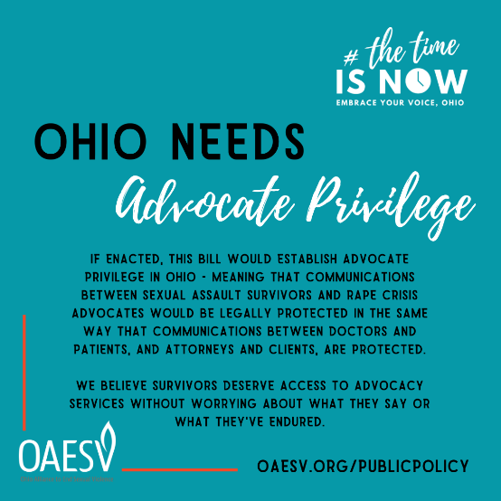
Caption:
Join us in the fight for Advocate Privilege! Learn more at www.oaesv.org/publicpolicy. #EmbraceYourVoice #TheTimeIsNow

Image:
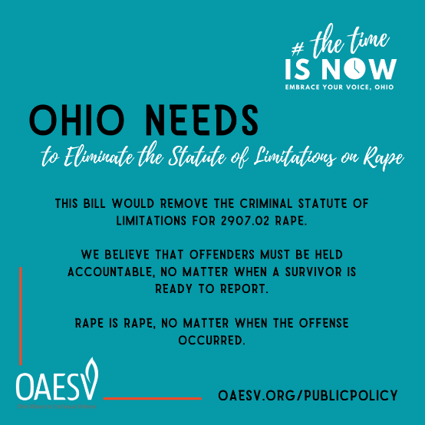
Caption:
Did you know that Ohio still has a statute of limitations on rape? Learn more about how you can help pass this important legislation by going to www.oaesv.org/publicpolicy #EmbraceYourVoice #TheTimeIsNow

Image:
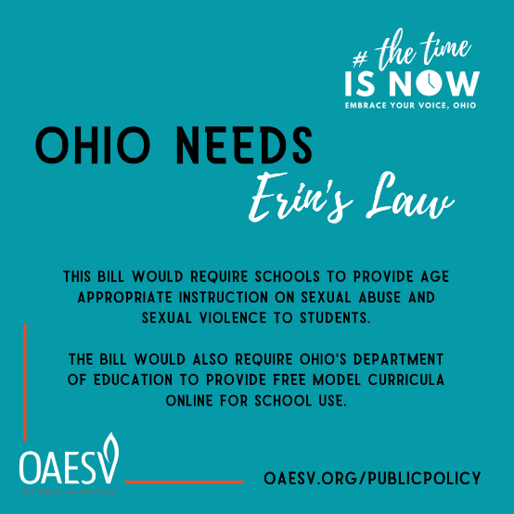
Caption:
Erin’s Law could help young people understand what sexual violence is. They often don’t know how to recognize these things, even if it’s happening to them. Age-appropriate education on these topics would help Ohio’s youth! #EmbraceYourVoice #TheTimeIsNow

