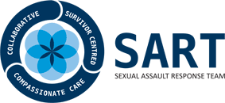

(INSERT COUNTY) SEXUAL ASSAULT RESPONSE TEAM
Statement of Collaboration
Mission Statement: The (Insert County) Sexual Assault Response Team (SART) is a multidisciplinary team committed to working together to ensure a consistent, holistic, victim-centered response to victims/survivors of sexual violence. Through nurturing and sustaining opportunities for collaboration, we will ensure the rights and safety of victims and accurate evidence collection to promote the apprehension and prosecution of perpetrators.

The (Insert County) Sexual Assault Response Team is committed to ongoing collaboration and participating agencies pledge to:
- Identify multidisciplinary representatives from each agency who are stakeholders in addressing sexual assault occurring within Brooke and Hancock Counties.
- Engage in an ongoing dialogue through regularly established meetings with identified representatives to promote enhanced communication and increase understanding of the roles and responsibilities of all participants.
- Make efforts to discuss and implement innovative, victim-centered practices established by the team and address service gaps as they are discovered.

Agency Name Signature

