OAESV Branding Guidelines & Tips

In order to continue creating consistent and engaging publications, OAESV has a few branding guidelines (must be followed) as well as some tips (just suggestions). Please apply these when creating any publication on behalf of the organization. Additionally, if someone from another organization is making a flyer or otherwise using our logo, branding, or organization name, the Resource & Communications Team should see and approve the document before it is published.

The main aspects of our branding guidelines include:
- Logo
- Colors
- Fonts
- Grant Language
- Mission-driven messaging

LOGO

Please find the logo file in our organization Dropbox and always use this file when using the logo; this helps ensure that it is the best quality logo each time. This file also has no background, which is how we want our logo to be shown, not with a white background. See example below. In order to keep the file’s ability to appear with no background, you must keep it as a PNG file type (not JPEG or other file type).

If you are using the logo on a teal background, or other background that makes it hard to see, please consider using the all-white or all-black version of the logo in Canva.

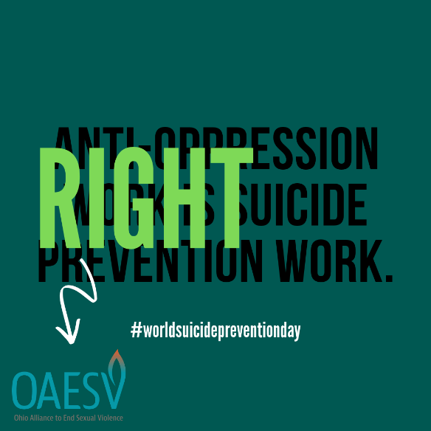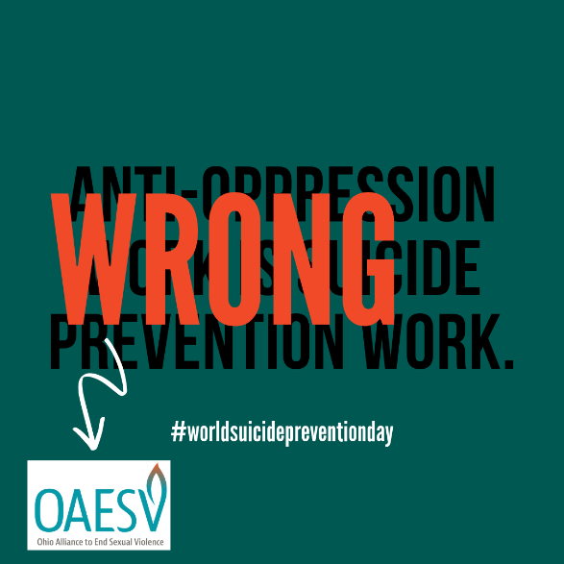

- Always ensure that the logo is easily seen (not obstructed by other images).
- Always ensure that the logo has breathing room around it (not crammed up right next to another image).

If you are creating an event or email in Constant Contact, be sure to include our logo centered at the top (or somewhere on the landing page/email where it looks nice).

The correct file is already in the uploads/”My Library” there, so you will just have to “insert” it. After you insert, it should give you the option to resize. If it doesn’t, you can click “customize” instead of “insert”. A size of 150 x 94 is suggested.

COLORS

We have exact color codes for our brand colors. They are already loaded into our Canva account for ease of use with that program. If you need to use a program other than Canva to create a graphic/flyer, you will need these color codes (see below). Please also share them with other folks who are making anything with our logo or branding attached.

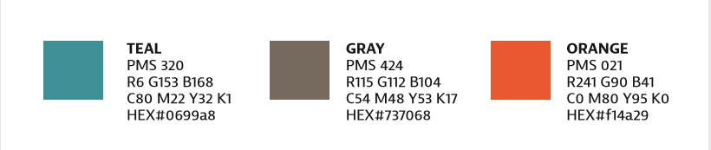

FONTS

Use Roboto Condensed in everything except resources, documents printed third-party, and major projects. For those, reach out to the comms team so we can apply our logo font.

In general documents and promotions, you can use fonts that appeal to you. Just focus on accessibility and legibility, as well as design. Is it crisp, clear, and large enough to be read at 100% view? Use at least 11-point font when you can. In Canva, Bebas Neuve as well as Monteserrat Classic (and Light) are very close to our branded logo font (see below). In Microsoft products, Cambria or Calibri are always good choices, but the closest to our branded logo font is Roboto Condensed. We suggest using Roboto Condensed most often. For many, Roboto Condensed will need to be downloaded and installed. Here is the file, and here are the instructions.

For resource documents, documents printed by a third party, and major projects, our logo font should be used. This is Bernina Sans in Adobe. Unfortunately, this font is only available to those using an Adobe Creative Cloud subscription. The communications team can help apply this font in these situations.

GRANT LANGUAGE

Everything we print, publish, share--whether electronically or in paper—must have all applicable grant disclaimers. This includes training flyers, newsletters, annual reports, brochures, PowerPoint presentations created by staff, webinar flyers, and more.

Please note that some funders require us to submit publications for approval at least 20 days prior to using, printing, distributing.

A good place to put grant language is at the bottom of your image or document, in font that is a size or two smaller than the body font.

MISSION-DRIVEN MESSAGING

Remember that all of our messaging, vocabulary, etc. should always point back to our mission and vision of ending sexual violence and empowering survivors with an anti-oppression lens. Please take care and intention to ensure the language you use in publications aligns with this. Review our mission, vision, and strategic plan often to re-center yourself and your work.

