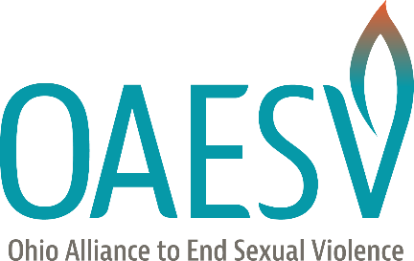
General Sexual Violence Advocacy and Prevention Talking Points
[Please customize by adding your logo, program name, and talking points specific to your program and community. This can also be altered for specific news items and events.]
- At [program name] we center our work on believing and supporting survivors. Our society has a habit of accusing survivors of lying, and we want to flip that in our community.
- We start by listening without judgement. People who’ve been harmed deserve a safe for them to share their experiences. That space can be [program name].
- Survivors of all genders, ages, races, and sexualities exist. Unfortunately, this is a problem that spans every group in our community.
- Survivors are the experts of their own lives and healing journeys. At [program name], we assist and support in that journey, and we follow the survivor’s lead.
- Due to reactions rooted in shame and disbelief, it can be hard for survivors to come forward. We know it can take time for survivors to open up or to seek help. It’s very common for someone to share their story for the first time after decades, or to never share at all.
- We’ve seen through research that prevention of violence, including sexual violence is possible, but we need everyone in the community to join [program name] in this shift.

